**Title Page**

**Executive Summary**

Adjust font size to 11 for all paragraphs

**Table of Contents**

# 1. Introduction

## 1.1 Purpose of the report

## 1.2 Issues to be discussed and their significance

## 1.3 Research methods

## 1.4 Limitations and assumptions

# 2. Discussion

## 2.1 Method

### 2.1.1 Procedures

### 2.1.2 Sample size

### 2.1.3 Selection criteria

## 2.2 Discussion and analysis of data

### 2.2.1 Issue 1

### 2.2.2 Issue 2

### 2.2.3 Issue 3

### 2.2.4 Reliability and accuracy of data

# 3. Conclusions

# 4. Recommendations

## 4.1 Recommendation 1

## 4.2 Recommendation 2

# 5. References

# 6. Appendices

# 1. Introduction

## 1.1 Purpose of the report

The purpose of this report is to investigate the steady-state heat distribution in a newly designed custom electronic component and provide its performance specifications. A mathematical model for the heat distribution in the component was developed and solved using numerical strategies. This report will also investigate the efficiencies of the various mathematical solving and data storage methods.

The schematic of the electronic component is shown in Figure 1. The placement of the component within the electronic device results in different temperatures along the boundaries of the component. The boundary AB (red) maintains perfect thermal contact with another component, which has a known temperature of 70°C. The boundary CD (purple) also maintains perfect thermal contact with another component, which has a known temperature of 40°C. The boundary AED (green) is thermally insulated, and the boundary BC (blue) is exposed to the ambient air temperature.

Figure 1: Schematic of electronic component

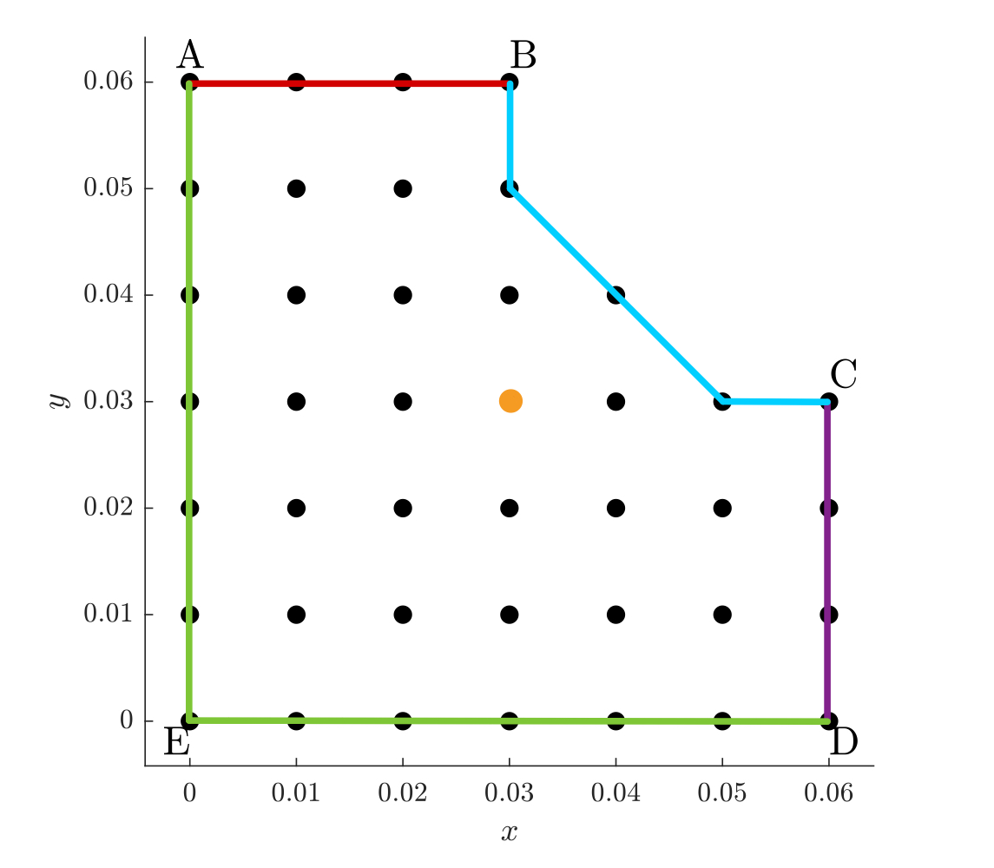

## 1.2 Issues to be discussed and their significance

The custom electronic component is to be marketed globally, so the component needs to meet specific performance specifications for this to occur. The component must maintain a temperature between 50°C and 55°C at the point (0.03, 0.03). This point (orange) is shown on Figure 1 in Section 1.1. The component will not function properly outside of these temperatures. This report will investigate the ambient temperatures that the electronic component can be exposed to and maintain a workable temperature at that point.

## 1.3 Research methods

Mathematical models and numerically solving

## 1.4 Limitations and assumptions

- model only – all models have inherent assumptions, can not perfectly represent reality

# 2. Discussion

## 2.1 Method

### 2.1.1 Mathematical Model

The mathematical model for steady-state heat distribution, in the absence of sources or sinks, is given by Laplace’s equation. Let *T(x, y)* represent the temperature of the electronic component at point *(x, y)*. The mathematical model for the component is as follows:

### The thermal conductivity *k* = 3 *Wm-1C-1*, and heat transfer coefficient *h* = 20 *Wm-1C-1* are known and remain constant throughout the investigation. Initially it is assumed the ambient temperature is *T*∞ = 20°*C*.

### The electrical component model is converted to a matrix problem by discretising the surface area domain and forming finite difference equations. The domain is discredited by converting the continuous surface area into discrete counterparts using a mesh of squares. A node is assigned to each internal corner of the mesh, as shown in Figure X. The nodes along boundaries AB and CD are not assigned as the temperature value at these nodes remains constant throughout the investigation. All nodes along the AB boundary will remain a constant 70°*C* and all nodes along the CB boundary will remain a constant 40°*C*.

### 

### The interior nodes (8, 9, 10, 11, 12, 14, 15, 16, 17, 18, 20, 21, 22, 23, 26, 27, 28, 31 and 32), as shown in blue in Figure X, are all solved for in the same way, using Node 15 as an example:

### 

### Let node 15 = u15, node 9 = u9, node 13 = u13, node 16 = u16, and node 21 = u21, as shown in Figure X.

### The nodes along the ED boundary (2, 3, 4, 5 and 6) are solved as follows, using Node 3 as an example:

### Let node 3 = u3, node 2 = u2, node 4 = u4, node 9 = u9, and let uS be the ghost node south of node 3, as shown in Figure X.

(1)

### Solve for uS using the insulated (Neumann condition) boundary equation, .

(2)

### Sub (2) into (1).

### The nodes along the AE boundary (7, 13, 19, 25 and 30) are solved as follows, using Node 13 as an example:

### Let node 13 = u13, node 7 = u7, node 14 = u14 and node 19 = u19, and let uW be the ghost node west of node 13, as shown in Figure X.

(3)

### Solve for uW using the insulated (Neumann condition) boundary equation, .

(4)

### Sub (3) into (3).

### Node 1 is solved for as follows:

### 

### Let node 1 = u1, node 2 = u2, node 7 = u7, and let uW be the ghost node west of node 1 and uS be the ghost node south of node 1, as shown in Figure X.

(1)

### Solve for uW and uS using the insulated (Neumann condition) boundary equation, .

### 

(2)

### Sub (2) into (1).

### 

### Node 29 is solved for as follows:

### Let node 29 = u29, node 28 = u28, node 23 = u23, and let uE be the ghost node east of node 29 and uN be the ghost node north of node 29, as shown in Figure X.

(3)

### Solve for uE and uN using the convective (Robin condition) boundary equation, .

### 

(3)

### Sub (3) into (4) and sub in constants.

### 

### Node 24 is solved for as follows:

### Let node 24 = u24, node 23 = u23, node 18 = u18, and let uN be the ghost node north of node 33, as shown in Figure X. The node east of node 24 is known to be 40°C.

(3)

### Solve for uN using the convective (Robin condition) boundary equation, .

(4)

### Sub (4) into (3).

### Sub in *a* and *b* and constants.

### Node 33, which is similar to node 24, is solved for as follows:

### 

### Let node 33 = u33, node 32 = u32, node 28 = u28, and let uE be the ghost node east of node 33, as shown in Figure X. The node north of node 33 is known to be 70°C.

(5)

### Solve for uE using the convective (Robin condition) boundary equation, .

(6)

### Sub (6) into (5).

### Sub in *a* and *b* and constants.

### 2.1.2 Numerical Approach

Text here

### 2.1.3 Direct Methods

Text here

### 2.1.4 Iterative Methods

Text here

### 2.1.3 Node Re-Orderings

Text here

## 2.2 Discussion and analysis of data

### 2.2.1 Method Performance

Text here

### 2.2.2 Issue 2

Text here

### 2.2.3 Issue 3

Text here

### 2.2.4 Reliability and accuracy of data

Text here

# 3. Conclusions

Text here

# 4. Recommendations

## 4.1 Recommendation 1 – compentent specfications?

Text here

## 4.2 Recommendation 2 – data storage efficieny?

Text here

# 5. References

Chapter Notes – how to reference

# 6. Appendices

Text here

$$\begin{aligned}\frac{∂^{2}T}{{∂x}^{2}} + \frac{∂^{2}T}{{∂y}^{2}} = 0 \#Laplace's equation- in the interior\end{aligned}$$

$$\begin{aligned}T=70 \#Dirichlet condition equation- on boundary AB\end{aligned}$$

$$\begin{aligned}T=40 \#Dirichlet condition equation-on boundary CD\end{aligned}$$

$$\begin{aligned}∇T∙\hat{n}=0 \#Neumann condition equation-on boundary AED\end{aligned}$$

$$\begin{aligned}k∇T∙\hat{n}=h\left(T_{∞}-T\right) \#Robin condition equation-on boundary BC\end{aligned}$$